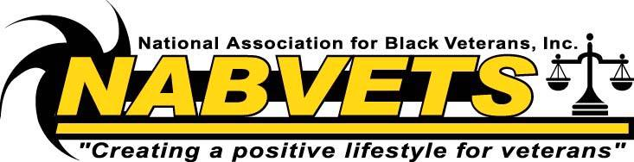

Delaware Chapter #0094

Dear Family and Friends:
I am excited to announce that I have recently become a member of a non-profit association serving veterans in Wilmington, Delaware. The National Association of Black Veterans, Inc, Delaware Chapter #0094 was organized to foster the intellectual, economic, socio-cultural, collective good and well being of all veterans in general and Black veterans in particularly. For nearly 35 years, the National Association for Black Veterans, Inc. (NABVETS) has offered services such as:
- Benefits pertaining to Health care
- Rehabilitation
- Employment
- Housing
- Education
- Transportation
- Economic Assistance
- Monuments that honors all veterans
The National Association for Black Veterans, Delaware Chapter #0094 is currently conducting an annual fundraising campaign. I hope that you can join me as a participant by donating a minimum of $20.14 to commemorate the year 2014. Please complete the enclosed insert and make checks or money orders payable NABVETS Delaware Chapter #0094. As a 501c3 organization, all contributions are tax-deductible.
Enclosed is our flyer for your review. If you have any more questions regarding our programs, feel free to call (302) 345-6911 and someone will contact you within the next week. Help us to continue “creating a positive lifestyle for veterans”.

Sincerely,
Nolan S. Lewis, Commander
NAVBETS Delaware Chapter #0094

Delaware Chapter #0094
Please complete the below information and mail it along with your checks or money orders to:

NABVETS Delaware Chapter #0094

P.O. Box 2231

Wilmington, De 19899
Name: ________________________________________________________________
Address: ______________________________________________________________
City: ________________________________ State: _______ Zip Code: __________
Donation Amount:____________
Thank you for your support of our heroes/veterans
---------------------------------------------------------------------------------------------------------------------
Please complete the below information and mail it along with your checks or money orders to:

NABVETS Delaware Chapter #0094

P.O. Box 2231

Wilmington, De 19899
Name: ________________________________________________________________
Address: ______________________________________________________________
City: ________________________________ State: _______ Zip Code: __________
Donation Amount:_____________
Thank you for your support of our heroes/veterans

